Dokumentation DMMS WS24_25

Welches Ziel verfolgen wir?

Wir wollen mithilfe unserer Recherchen, Erkenntnisse und gesammelten Informationen dazu beitragen, das Leben und den Alltag von demenzkranken Personen zu erleichtern.

Recherchearbeit:

1. Interview mit einem Betroffenen

TL;DR 🡪 professionelle Distanz wahren, Respekt und Würde als wichtigste Vorsätze, Humor zur Verbesserung der Lebensqualität, soziale Interaktion als essentieller Faktor im Umgang mit Demenzpatienten

Das erste Gespräch führten wir mit dem Enkel des Betroffenen, welcher uns darüber aufklärte, dass die Thematik Demenz weitreichender ist, als wir anfänglich vermutet haben. Die Wohnsituation ist ein erstes Hindernis, da modernste Technik wie Tracking Systeme und smarte Feuerlöschsysteme und Sensoren zur Überwachung der Luftqualität benötigt werden. Um ein Fehlverhalten zu vermeiden, sind simple und leicht verständliche Ablenkungsaufgaben unvermeidbar. Die Angehörigen leiden, so laut dem Enkel, auch unter einer starken psychischen und emotionalen Belastung. Mit der Zeit wurden die Familie desensibilisiert und eine unfreiwillige Akzeptanz trat ein. Für die Frau liegt ein erhöhtes Stresslevel, dass durch die ständigen Sorgen entsteht, vor. Der starke Konsum von Alkohol kann sich zusätzlich auch noch negativ auf den Verlauf der Demenz auswirken. Die täglichen Herausforderungen entstehen in den für uns normalsten Tätigkeiten, welche wir nebenbei erledigen können; Essen, Trinken oder die Einnahme von Medikamenten erfordern erhöhte Aufmerksamkeit und Energie. Um das Vorgehen zu erleichtern, sind klare, einfache Anweisungen für den Betroffenen von Vorteil. Da es so gut wie unmöglich für die Familie ist, jede Aufgabe im Leben des Betroffenen zu übernehmen, haben sie sich um Unterstützung durch Dritte gekümmert. Zur Hilfe kommen nun eine Tagespflege und die Caritas, welche mit geschultem Personal helfen. Die Sicherheit des Ehepaars ist auch gefährdet, da der Patient nicht mehr unterscheiden kann, wer bei ihm an der Tür klingelt und somit jeden in sein Haus lässt, was ein fatales Sicherheitsrisiko für die beiden Rentner birgt. Zusammenhängend damit fällt es ihm sehr schwer, Leute noch zu erkennen und den Bezug zur Identität herzustellen, sodass er beim Betrachten von verschiedenen Menschen starke Probleme hat, sie auseinanderzuhalten oder zu differenzieren. Im Anschluss an das Interview ging es an die Auswertung, Zusammenfassung und Kategorisierung der gewonnenen Informationen.

Sidenote: Was soll das Gerät besitzen?

* Elevator pitch -> more specific -> device that helps patients live their live and to prevent dangerous situations -> using computer vision e.g. -> supposed to relief relatives/workers from the stress
* Persona: different stakeholders in one persona is not good -> you try to create one persona -> google -> image or photo -> emphasize much easier -> typical age, living situation -> from POV: what do we want to achieve? Are they afraid? What benefits would be good for them?
* Customer journey: Describe how the device helps the people into the daily life. How is it talking to the person? Make specific scenarios? Before or while the action? Taking the view from a psychologist view –> when should the device take over? Too early or too late? Depression and frustration should be not coming up by all means! How will the device talk to the person? Conversation style? Just commands? “It’s all about psychology.” “Do I accept the character I feel behind this thing?” Goal is to achieve a realistic character where the patient is comfortable to have as a partner in everyday life. “Interaction is key”.

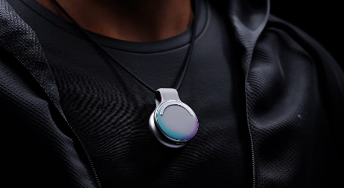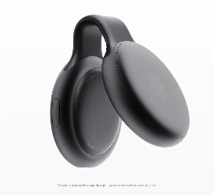After talking about the rough first design of the device we all settled on some research first. Everyone took his time and looked for similar design proposals which he thinks are similar and suitable for our scenario. 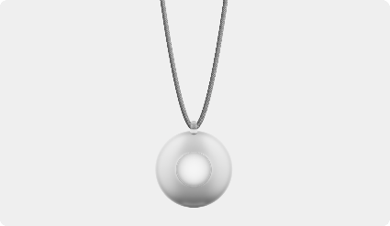

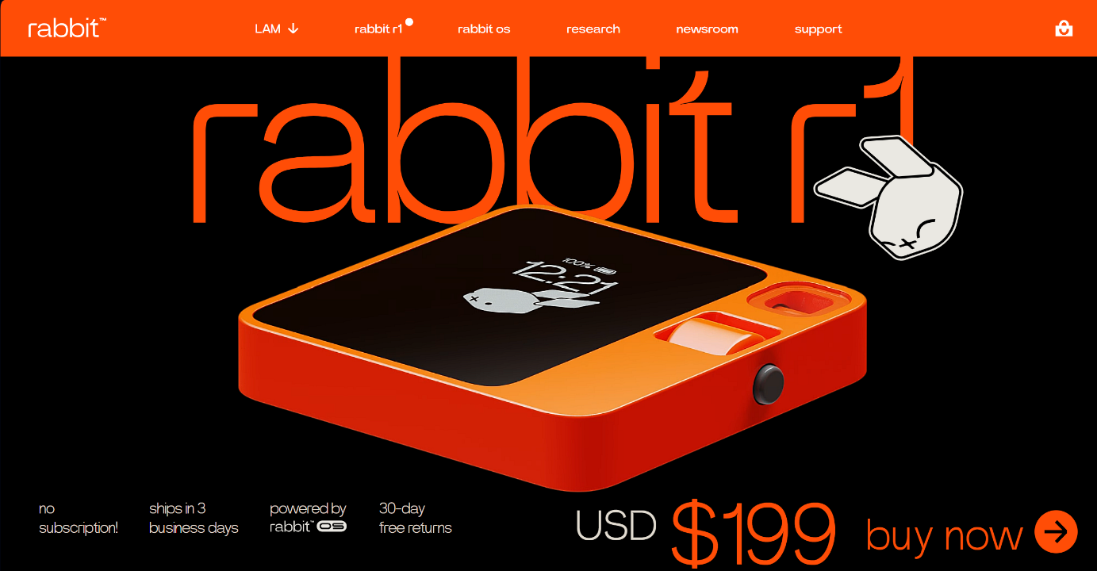

From our different point of views we got a concurring guideline for the design. To

Visualize our concept and to make the device more genuine we started to draw

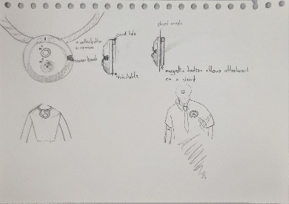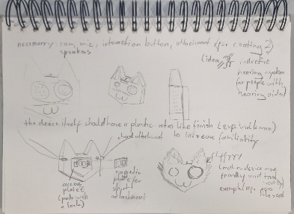 Some sketches which you can see here:

Ein Bild, das Text, Handschrift, Papier, Brief enthält.

After visualizing our thoughts and imaginations we wanted to focus on the appearance of the device. We were sure that custo, that’s the name for the wearable (coming from latin custodire; Meaning to protect, to look after -> custody) has to have a SOS Button for the carrier, a small buit in camera, a speaker and various sensors like GPS etc.Although we were clear of our hardware specs, we still had to dive deeper into the software and communication side. We asked ourselves following questions to get the needed answers for further development: How should the device interact with the patient? What relationship should develop between device and patient? Is the ability to talk to the patient useful? Do we need buttons on the device? We came to the conclusion that the device should be trustable, charismatic, emphatic, approachable and discreet. To combine all these big attributes into one little wearable is much more difficult than we thought at the beginning of the project. To find a good balance between conductive and insightful behavior is not very easy. We decided to go for a face-like design to let it appear more friendly and warm to the patient. Furthermore, a round and oval shape suggests a familiar carrying comfort either pinned to the clothing or worn as a chain around the neck. The relatives of the patient should be able to track the device and its owner by gps and the custom made website so in case the patient runs away or gets lost on the streets they can help. Remote access to the camera is also an essential function of the website to ensure a quick look through the wearers eyes. With an AI implementation the device should detect by itself if the patient gets himself into any danger. For example, if a the oven is on and the device didn’t see the oven for more than 10 minutes it gives an reminder that the oven could still be on. We made three separate user interviews. Nick talked with his grandmother and with his father. Vincent with his mother. For the interviews we prepared a form with different questions regarding Custo to get a deeper insight into outsiders opinions. Following questions were asked:

1. a relative in your environment is affected by dementia. You are now presented with a device that can be worn by the person affected and supports both the wearer and the caregiver. How likely is it that you will take a closer look at the product?
2. various sensors such as GPS, a camera and a microphone are built into our product to provide the best possible support. These can also be called up remotely via a web application, so that access is possible despite physical distance. In your opinion, is this too much of an invasion of the wearer's privacy or does the feeling of security and control give you peace of mind as a relative?
3. What do you think the device should look like (put yourself in the shoes of someone affected) in order to be worn daily, regularly and with a good feeling? Rather friendly and trendy? Rather inconspicuous and unobtrusive?
4. Here you can see a first design draft from us. What do you like? What would you change?
5. Would you be confident enough to set up the device for the first time using a smartphone or internet-enabled device with the help of step-by-step instructions? What should these instructions look like?
6. How should the interaction be designed so that you feel comfortable with it (put yourself in the position of a person affected again) and are motivated to interact with the device on a daily/regular basis? Should a certain type of dialog be conducted? How would you like to be addressed? At what frequency (once a day or every half hour, for example) should interactions take place?
7. We are planning to integrate an SOS button on the top of the device (currently the green button) which, when pressed, alerts the emergency contacts stored in the web application. What do you think about this? Should pressing the SOS button activate certain processes? What should happen then? How should the device be handled in general? Should the wearer have more active options to control the device haptically?

The results of the interviews lead us to the conclusion that we are on the right way but need to improve in some points like the SOS Button and also the appearance. We also have to improve the dialogue and make it more detailed. We also got positive feedback on the smiling design and on the overall idea. No one has said anything critical about the surveillance aspect and was rather happy about getting a new way to connect to their loved ones. After some feedback from Mrs. Ritzer we wanted to improve our moodboard and user journey to get a better understanding of the concept. We created a specific user journey for our persona and took a deeper dive into the expansion of our moodboard and wordcloud. We had the target to get a matching feeling/consistency between the pictures and the wordcloud because of a missing connection. We wanted to get a better structure into our research and results. Parallel to that we started to design the mobile website/app for Custo. We talked about the different possible color schemes, the layout, the most important functions, and the general navigation to make the app as easy to use for our target users. We also plan to improve the render quality of our 3d Model to give the people a better understanding of the design and the process. As the project evolved we also had to improve our concept and decide detailed what we need to improve the experience. We also talked to some more people about Custo and how they wish the webapp to be. We wanted to create a experience which suits for as much as possible target groups. The next step was to develop the web interface and create the custom screen designs.

PLACEHOLDER FOR SCREENDESIGNS!!!!!!

Parallel to the screendesign we had to start with the making of a product video. We sat together and talked about the script and how the style of the video should be. We came to the conclusion that it would be the best option to show Custo in common daily situations and how it works and interacts with its wearer. We also agreed on filming a realistic video because of the better visualization of Custo and a overall more natural feeling. To transform Custo into a real life object, we had to create a special file to 3d-print a dummy for the actor to wear. After a successful testrun we got our final real life Custo. Because it was printed in just one color (boring white) we also had to paint it so there would be no difference to our sketches. When the day of filming arrived, everyone was thrilled about how it would work out. After five hours we got everything we needed to start the post production of our film. We had to cut the scenes together and we also had to get a corresponding sounddesign so everything matches properly.